

Project Name: MEET YOUR DOCTOR

Branch PG-DAC Mar- 2022.

Documentation On

**“**MEET YOUR DOCTOR**”**

PG-DAC Mar 2022

### **Guided By: Mrs. Rupali Thorat**

Submitted By:

**Group No: G64**

* **Mohite Omkar Shivaji 220341220126**
* **Lokhande Kunal Kisan 220341220102**

**Table of Contents**

**1. Introduction 4**

1.1 Document Purpose **4**

1.2 Project Background **4**

1.3 Aim & Objectives **4**

**2. Business Requirements Overview**…………………………………………………………**5**

**3.Functional Requirements** **5**

3.1 Admin Module **5**

3.2 Doctor Module **6**

3.3 Patient Module **6**

**4.** **Non-Functional Requirement………………………………………………………………6**

**5. Use Case Diagram 7**

5.1 Admin **7**

5.2 Doctor **8**

5.3 Patient **9**

**6. Database Design 10**

1 Login **10**

2 Doctor **10**

3 Patient **10**

4 State **11**

5 City **11**

6 Area **11**

7 Doctor Time Table **11**

8 Appointment **12**

**7. E-R Diagram………………………………………………………………………………………13**

**8. Snapshots 14**

**9. Conclusion 30**

**List of Figures**

**Use Case Diagrams 7**

Fig 1 Admin 7

Fig 2 Doctor 8

Fig 3 Patient 9

Fig 4 ER Diagram 12

# ABSTRACT

This project is a web-based Appointment Booking System for Patients. The project objective is to Automate booking System into web platform.

This project is an attempt to provide the advantages of online Appointment Booking System to Patient to Book Appointment with Doctor. It helps to Book Appointment with Doctor through internet by using a website. Thus, there no need to stand in queues for appointment booking. This system is independent website where Patient and Doctor can register and patient can view doctors and book appointment.

Using our Website the patient can see doctor according to their area , specialty , services, and qualification and can pay doctor fees online by through portal and save there valuable time.

**ACKNOWLEDGEMENT**

I take this occasion to thank God, almighty for blessing us with his grace and taking our endeavor to a successful culmination. I extend my sincere and heartfelt thanks to our esteemed guide, **Mrs. Rupali Thorat** for providing me with the right guidance and advice at the crucial juncture sand for showing me the right way. I extend my sincere thanks to our respected **Centre Co-Ordinator Mr. Prashant Karhale**, for allowing us to use the facilities available. I would like to thank the other faculty members also, at this occasion. Last but not the least, I would like to thank my friends and family for the support and encouragement they have given me during our work

1. **Introduction:**
   1. **Document Purpose:**

This document explains the system requirements and scope for developing Meet Your Doctor portal. Meet Your Doctor portal could divide the three main parts, Admin part, Patient part and Doctor part.

## Project Background:

During pandemic Covid-19 was on high priority and almost all doctors were on duty at Covid-19 care centers which lead to negligence towards other diseases. Many patients suffered amidst pandemic due to unavailability of doctor’s appointment. Lockdown restrictions made it more difficult to get information about available appointment slot and doctor’s availability. Conventional medical treatment and health checkup is proven to be not feasible in these pandemic-like situations. There must be some virtual medium which will provide ease to both patients and doctors.

## Aim & Objectives:

* The purpose of our Project “Meet Your Doctor” is to automate the process of getting medical treatment and health checkup in a way that saves both time and effort.
* This application manages all the information of patients and doctors.
* The project is developed at administrative end and thus only the administrator is guaranteed to have access to everything.
* This web application reduces the manual efforts of looking for a doctor and booking appointments.

1. **Business Requirements Overview:**

* Meet Your Doctor is the public web application.
* Meet Your Doctor will be opened to the global, but in the phase 1, the main target is in the India.
* There are mainly two types of users. One is the Doctor and other is Patient.
* Patients can search for the available specialist Doctors in respective location.
* Doctor can create time table for appointment based on available time and can check information about the booked appointments.
* Meet Your Doctor provides the facility to connect the patients with the doctor efficiently.
* Meet Your Doctor could be maintained by Administrator.

# Functional Requirements Overview:

Meet Your Doctor consists of three modules described as below.

1. Admin Module
2. Doctor Module
3. Patient Module

# **Admin Module**

* Meet Your Doctor provides all functionality to admin how to handle the System.
* Admin can verify the new doctor when credentials found authentic.
* Admin has controls and can see the Patient Details and Doctor details.
* Admin can see the Doctor details and if admin found any details in-appropriate, admin can delete those entries.
* Admin can deactivate the Doctor temporarily or permanently.
* Admin can add Home Page video to improve look and feel of website

# **Doctor Module**

* Doctor can update his profile as per his/her requirements.
* Doctor can see the current appointments and appointment history.
* Doctor can cancel appointment in case of emergency.
* Doctor can update timetable according to availability and holidays.
* Doctor can change existing password.

# **3.3 Patient Module**

* Patient can update his profile as per his/her requirements.
* Patient can search doctors according to locality and specialty of doctor.
* Patient can see the current appointments and appointment history.
* Patient can pay fees online through Razorpay
* Patient can change existing password.

1. **Non-Functional Requirement:**

* The website should use professional design, look, and feel and color scheme.
* Users will have no limitations for accessing the application through Internet. The portal being an internet application, it is difficult to specify exact number of visitor or users.
* Being a public website, the site must follow general usability guidelines for menus, navigation, colors, links, and other actions provided on the screens.
* The system should be designed in such a manner that user will be able to complete tasks in minimum number of steps.

## 5. Use-Case Diagram

**5.1 Admin**

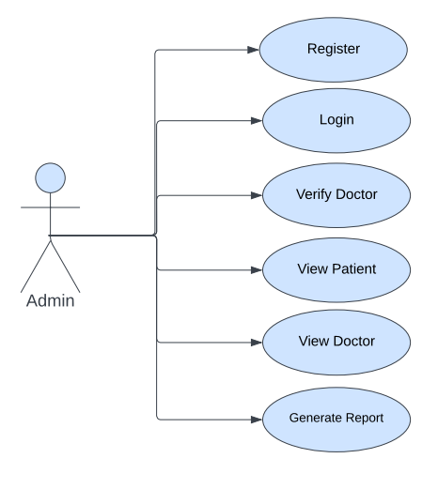

`Fig. Use-Case Diagram for Admin

## 5.2 Doctor

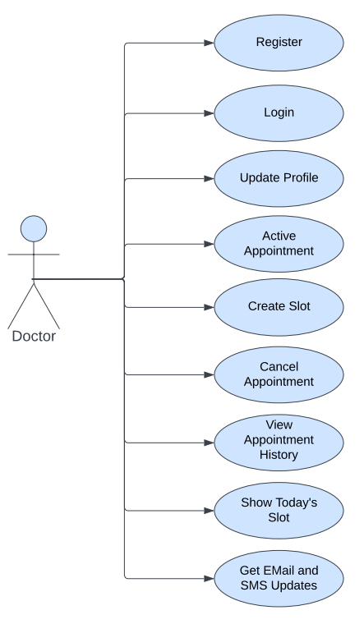

Fig. Use-Case Diagram for Doctor

**5.3 Patient**

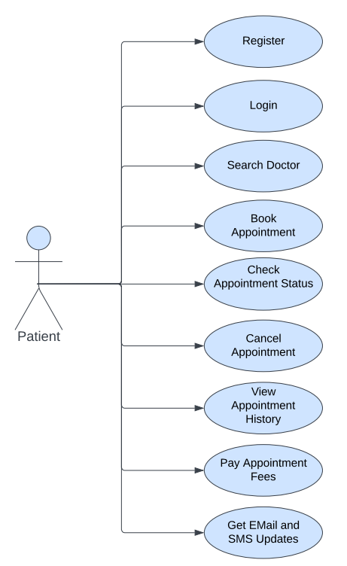

Fig. Use-Case Diagram for Patient

**6. Database Design:**

**1] Login table**

|  |  |  |  |  |
| --- | --- | --- | --- | --- |
| **Field** | **Type** | **Null** | **Key** | **Description** |
| id | Integer | No | Primary key | Login ID |
| user_name | Varchar(45) | No |  | User Name |
| password | Varchar(45) | No |  | User Password |
| otp | int | No |  | OTP |

**2] Doctor table**

|  |  |  |  |  |
| --- | --- | --- | --- | --- |
| **Field** | **Type** | **Null** | **Key** | **Description** |
| id | Integer | No | Primary key | Doctor ID |
| Aadhar_no | varchar (12) | No | Unique key | Aadhar Number |
| email | Varchar(35) | No |  | Email |
| first_name | Varchar(30) | No |  | First Name |
| last_name | Varchar(30) | No |  | Last Name |
| mobile_number | Varchar(14) | No | Unique key | Mobile Number |
| Alternate_mobile_number | Varchar(14) | No |  | Alternate Mobile  Number |
| gender | Integer | No |  | Gender |
| dob | date | No |  | Date Of Birth |
| fees | Integer | No |  | Fees |
| Profile Picture | Varchar(250) | No |  | Profile Picture |
| Is_doctor_suspended | BIT(1) | No |  | Doctor Status |
| is_doctor_verified | BIT(1) | No |  | Doctor Status |
| login_id | int | No | Foreign key | Login_id |

**3] Doctor Address Table**

|  |  |  |  |  |
| --- | --- | --- | --- | --- |
| **Field** | **Type** | **Null** | **Key** | **Description** |
| id | Integer | No | Primary key | ID |
| city | Varchar(30) | No |  | City |
| state | Varchar(30) | No |  | State |
| town | Varchar(30) | No |  | Town |
| country | Varchar(30) | No |  | Country |
| pincode | Integer | No |  | PIN Code |
| doctor_id | Int | No | Foreign Key | doctor_ID |

**4] Doctor Hobbies Table**

|  |  |  |  |  |
| --- | --- | --- | --- | --- |
| **Field** | **Type** | **Null** | **Key** | **Description** |
| doctor_id | Int | No | Foreign Key | Doctor_ID |
| hobby | Varchar(40) | No |  | Hobby |

**5] Doctor Speciality Table**

|  |  |  |  |  |
| --- | --- | --- | --- | --- |
| **Field** | **Type** | **Null** | **Key** | **Description** |
| doctor_id | BigInt | No | Foreign key | Doctor ID |
| Services_provided | Varchar(255) | No |  | Services Provided |
| Speciality_description | Varchar(255) | No |  | Speciality Description |
| Speciality_type | Varchar(255) | No |  | Speciality Type |
| Speciality_photo | Varchar(255) | No |  | Speciality Photo |

**6] Doctor Qualification Table**

|  |  |  |  |  |
| --- | --- | --- | --- | --- |
| **Field** | **Type** | **Null** | **Key** | **Description** |
| doctor_id | BigInt | No | Primary key | Doctor ID |
| Certificate_photo | Varchar(255) | No |  | Certificate Photo |
| education_type | Varchar(20) | No |  | Education Type |
| marks | double | No |  | Marks |
| year | int | No |  | Year |

**7] Bank account Table**

|  |  |  |  |  |
| --- | --- | --- | --- | --- |
| **Field** | **Type** | **Null** | **Key** | **Description** |
| Bank_acct_id | bigint | No | Primary key | Bank Account ID |
| ifsccode | Varchar(20) | No |  | IFSC Code |
| bank_account_number | Varchar(25) | No |  | Bank Account Number |
| bank_name | Varchar(50) | No |  | Bank Name |
| name_as_per_bank | Varchar(50) | No |  | Name as Per Bank |
| pan_card_no | Integer | No |  | Pan Card Number |

**8] Doctor time-table Table**

|  |  |  |  |  |
| --- | --- | --- | --- | --- |
| **Field** | **Type** | **Null** | **Key** | **Description** |
| timetable_id | Big Int | No | Primary key | Doctor Time Table ID |
| doctor_id | Integer | No | Foreign key | References doctor ID |
| weekday | Varchar(45) | No |  | Weekday |
| start_time | Time(0) | No |  | Start Time |
| end_time | Time(0) | No |  | End Time |
| break_time | Time(0) | No |  | Break Time |
| status | Varchar(45) | No |  | Status |

**9] Payments Table**

|  |  |  |  |  |
| --- | --- | --- | --- | --- |
| **Field** | **Type** | **Null** | **Key** | **Description** |
| payment_id | Big Int | No | Primary Key | Appointment ID |
| Order_id | Varchar(20) | No |  | Appointment Date |
| amount | number | No |  | Appointment Time |
| status | Varchar(10) | No |  | Appointment Type |
| razorpay_payment_id | Varchar(100) | No |  | Cancelled by |

**10] Patient Table**

|  |  |  |  |  |
| --- | --- | --- | --- | --- |
| **Field** | **Type** | **Null** | **Key** | **Description** |
| patient_id | Integer | No | Primary key | Patient ID |
| first_name | Varchar(30) | No |  | First Name |
| last_name | Varchar(30) | No |  | Last Name |
| mobile_number | Varchar(14) | No | Unique key | Mobile Number |
| alternate_mobile_number | Varchar(14) | Yes | Unique key | Alternate Mobile Number |
| gender | Varchar(20) | No |  | Gender |
| blood_group | Varchar(5) | No |  | Blood Group |
| dob | date | No |  | Date Of Birth |
| profile_picure | Varchar(250) | No |  | Profile Picture |
| login_id | Integer | No | Foreign key | Reference to login id |

**11] Patient Address Table**

|  |  |  |  |  |
| --- | --- | --- | --- | --- |
| **Field** | **Type** | **Null** | **Key** | **Description** |
| id | Integer | No | Primary key | ID |
| city | Varchar(30) | No |  | City |
| state | Varchar(30) | No |  | State |
| town | Varchar(30) | No |  | Town |
| country | Varchar(30) | No |  | Country |
| pincode | Integer | No |  | PIN Code |
| patient_id | Int | No | Foreign Key | Patient_ID |

**12] Patient Hobbies Table**

|  |  |  |  |  |
| --- | --- | --- | --- | --- |
| **Field** | **Type** | **Null** | **Key** | **Description** |
| patient_id | Int | No | Foreign Key | Patient_ID |
| hobby | Varchar(40) | No |  | Hobby |

**13] Appointment Table**

|  |  |  |  |  |
| --- | --- | --- | --- | --- |
| **Field** | **Type** | **Null** | **Key** | **Description** |
| appointment_id | Integer | No | Primary key | Appointment ID |
| appointment_date | date | No |  | Appointment Date |
| appointment_time | Time(0) | No |  | Appointment Time |
| appointment_description | Varchar(500) | No |  | Appointment Description |
| appointment_type | Varchar(45) | No |  | Appointment Type |
| status | Varchar(45) | No |  | Status |
| cancelled_by | Varchar(45) | No |  | Cancelled by |
| doctor_id | Integer | No | Foreign key | References doctor ID |
| patient_id | Integer | No | Foreign key | References patient id |
| payment_id | Integer | No | Foreign key | Payment ID |

**14] Appointment images Table**

|  |  |  |  |  |
| --- | --- | --- | --- | --- |
| **Field** | **Type** | **Null** | **Key** | **Description** |
| appointment_id | Integer | No | Primary key | Appointment ID |
| appointment_date | date | No |  | Appointment Date |

**15] User Role Table**

|  |  |  |  |  |
| --- | --- | --- | --- | --- |
| **Field** | **Type** | **Null** | **Key** | **Description** |
| user_id | Big int | No | Primary key | User ID |
| role_id | Big int | No | Primary key | Role ID |

**16] Role Table**

|  |  |  |  |  |
| --- | --- | --- | --- | --- |
| **Field** | **Type** | **Null** | **Key** | **Description** |
| id | Big int | No | Primary key | ID |
| role_name | Varchar(20) | No |  | Role Name |

**17] Home page images Table**

|  |  |  |  |  |
| --- | --- | --- | --- | --- |
| **Field** | **Type** | **Null** | **Key** | **Description** |
| id | Bigint | No | Primary key | ID |
| Home_images | Varchar(300) | No |  | Home Images |

**18] Public Table**

|  |  |  |  |  |
| --- | --- | --- | --- | --- |
| **Field** | **Type** | **Null** | **Key** | **Description** |
| id | Bigint | No | Primary key | ID |
| home_video_path | Varchar(250) | No |  | Home video |

## 7. ER-Diagram:

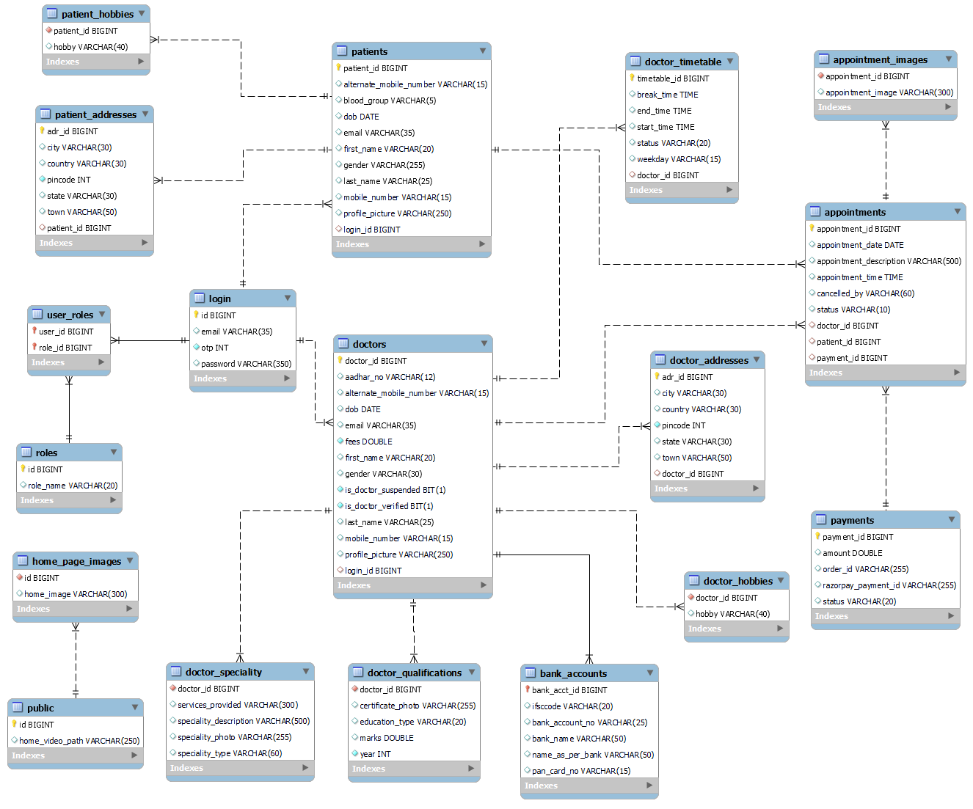

**E-R diagram shows database of Meet Your Doctor**

**8. Snapshots:**

**8.1 Home Page:**

Following snapshot shows the Home page for Meet Your Doctor.

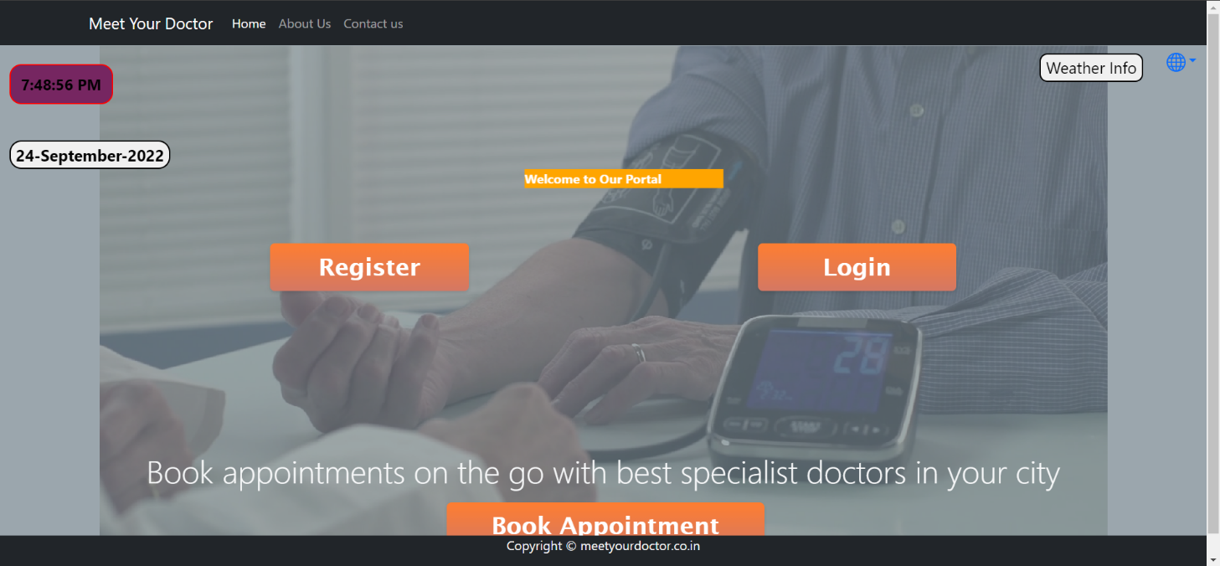

This page contains following controls

* Home
* About Us
* Contact Us
* Register (Patient, Doctor)
* Login (Admin, Doctor, Patient)

**8.2 About and Contact Page**

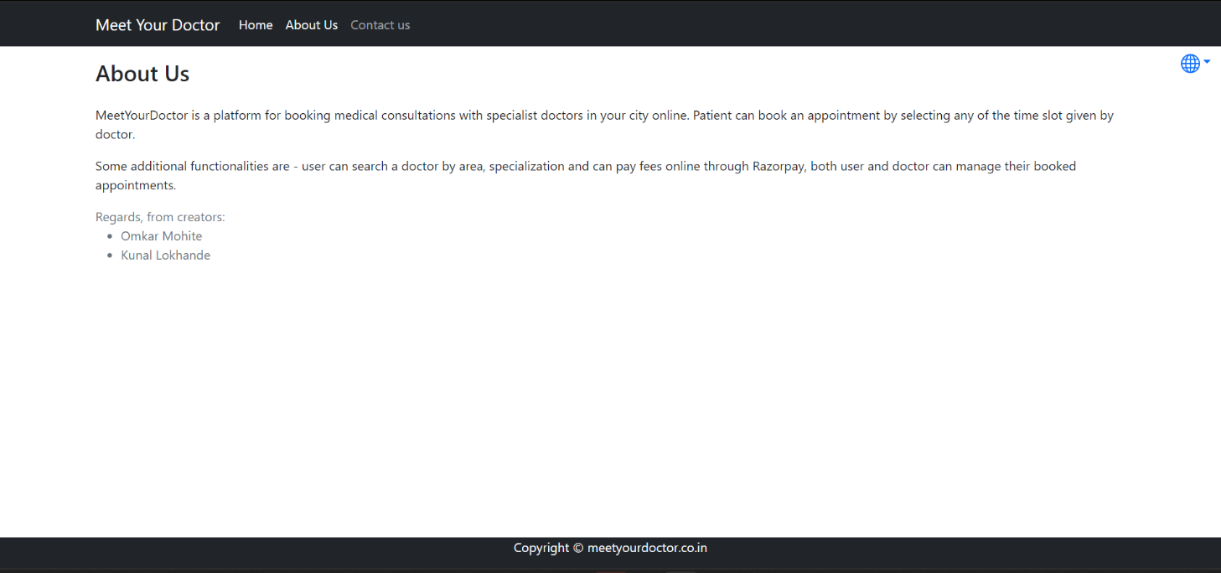

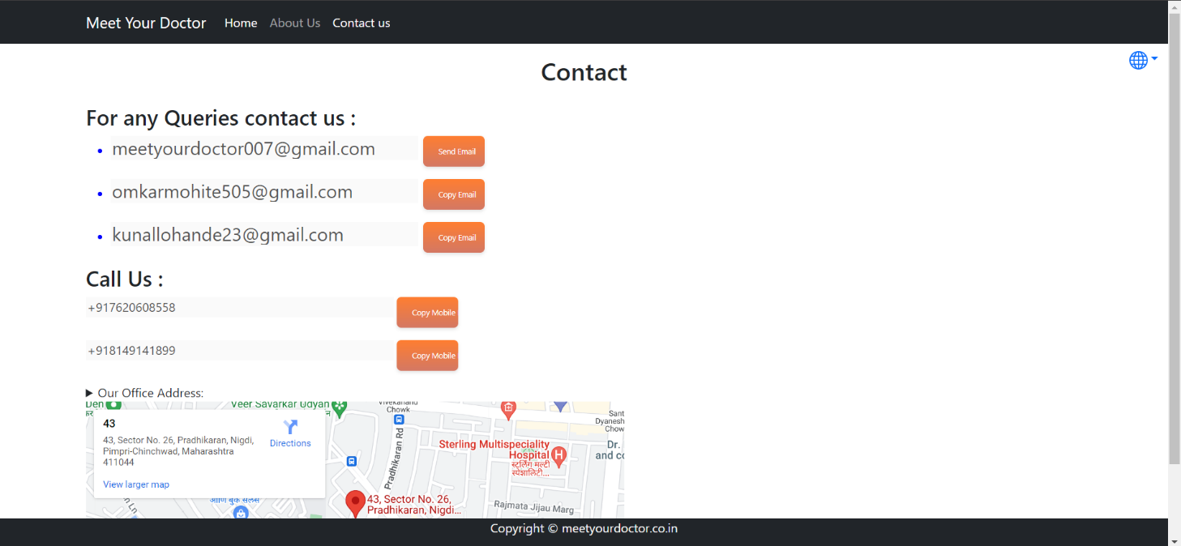

**8.3 Login Page**

Following snapshot shows the Login page for Meet Your Doctor.

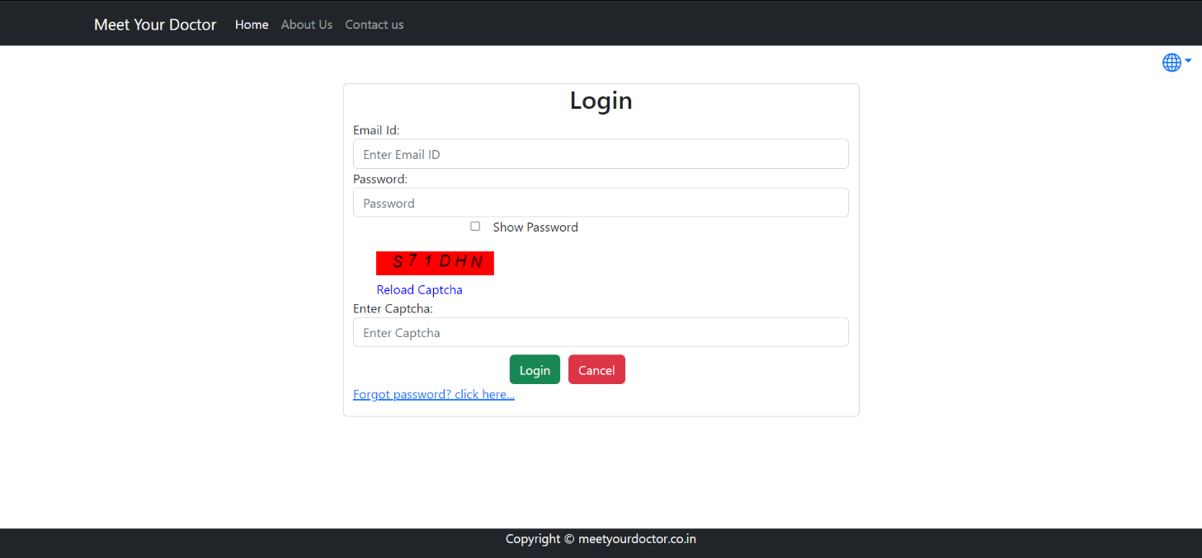

**8.4 Patient Registration Page**

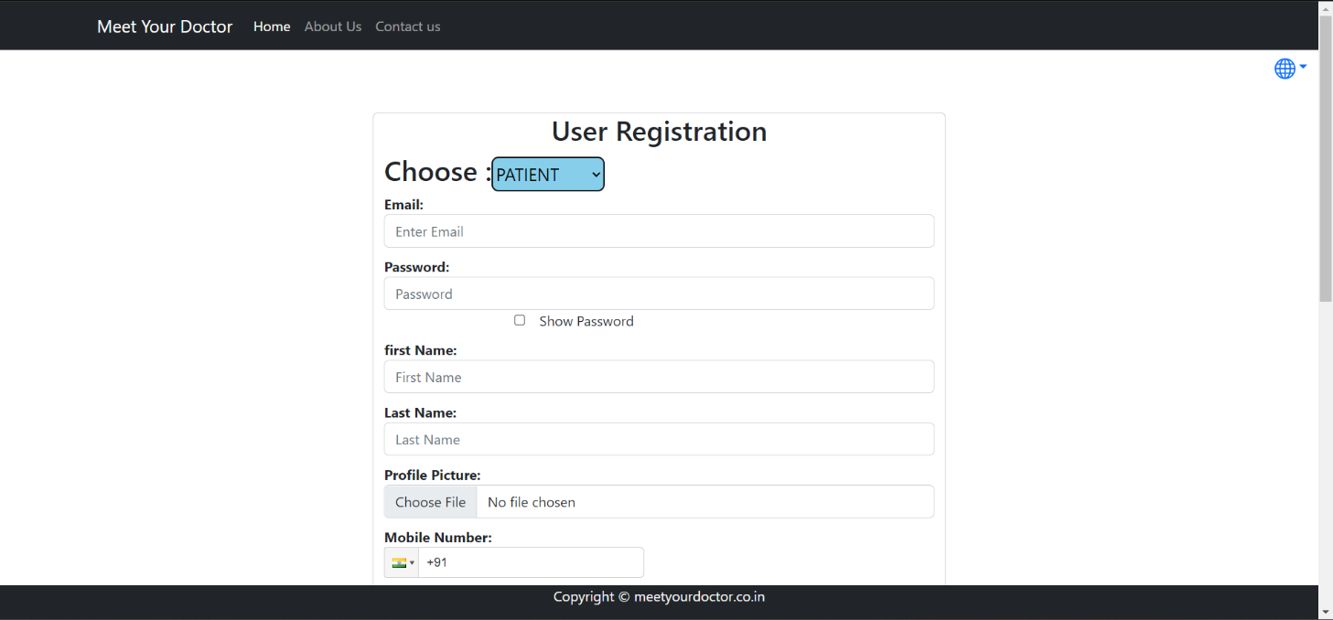

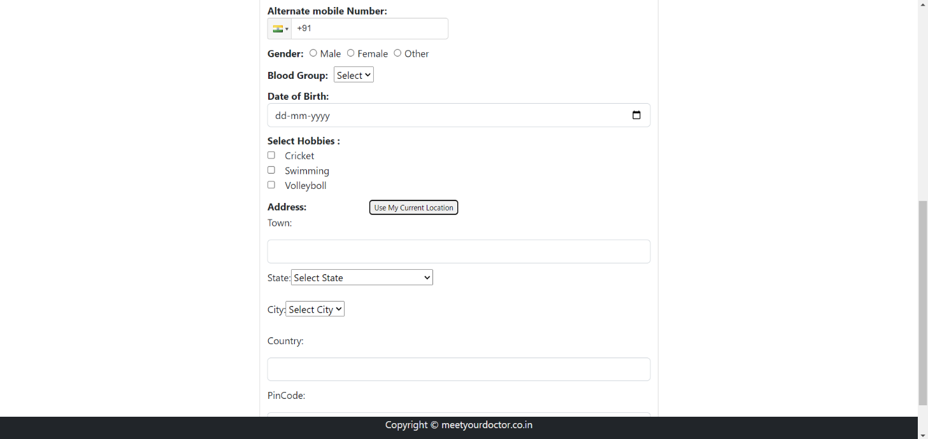

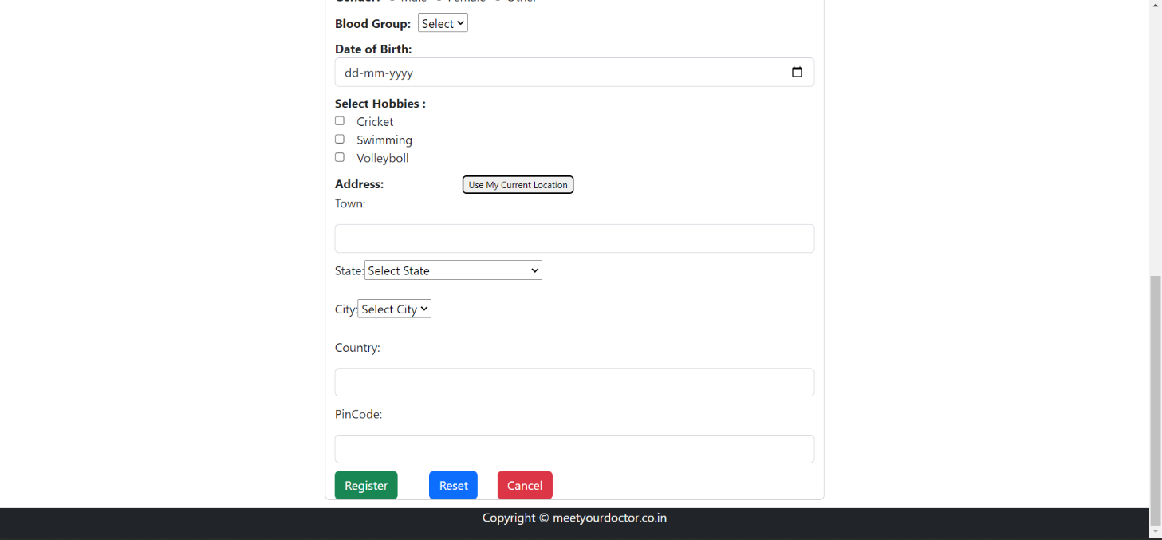

**8.4.1 Patient Home Page**

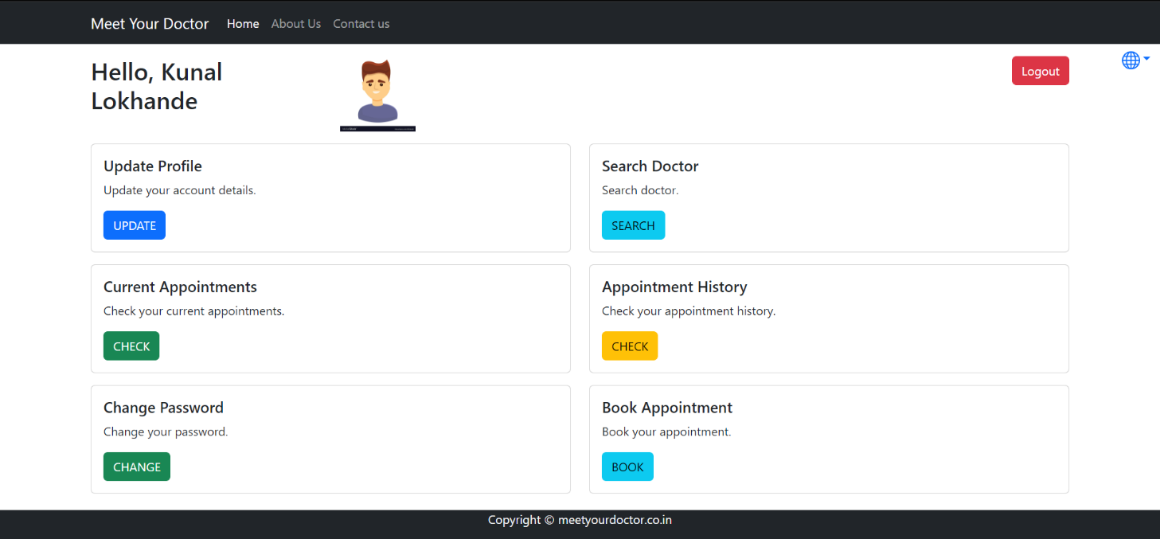

**8.4.3 Patient Search Doctor**

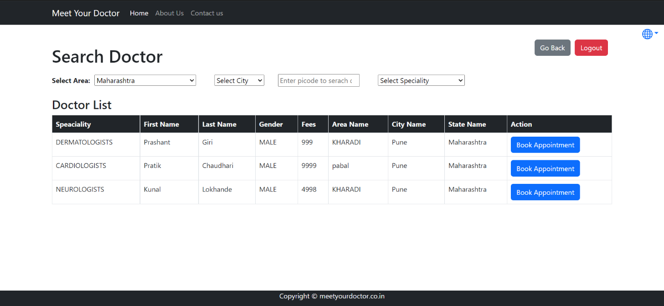

**8..4 Patient Current Appointment**

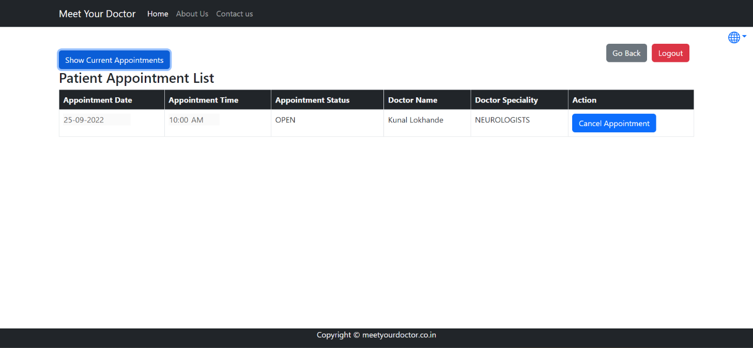

**8.4.5 Patient Appointment History**

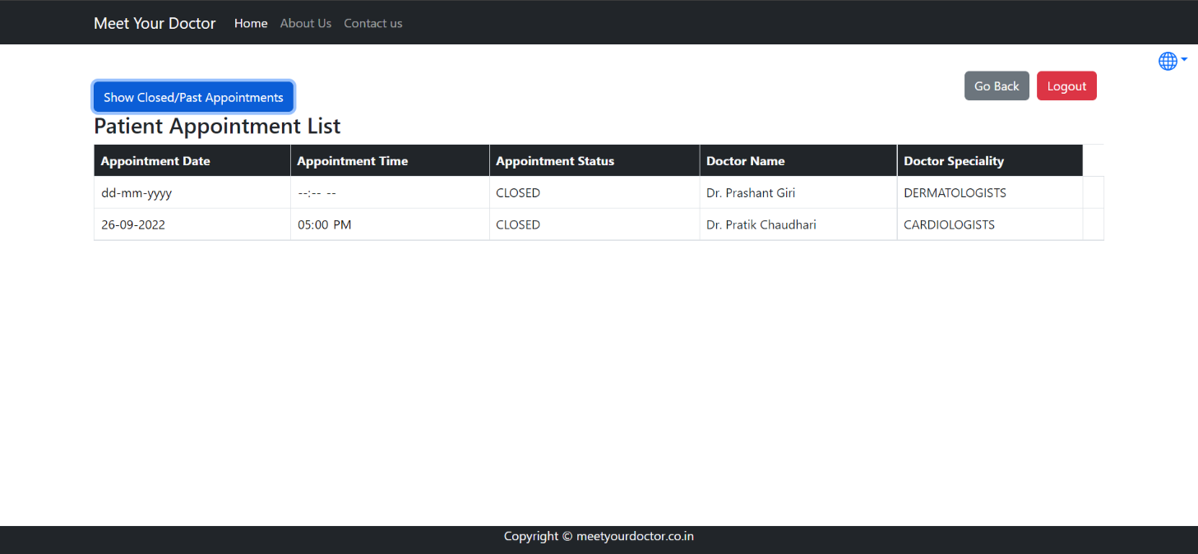

**8.4.6 Patient Change Password**

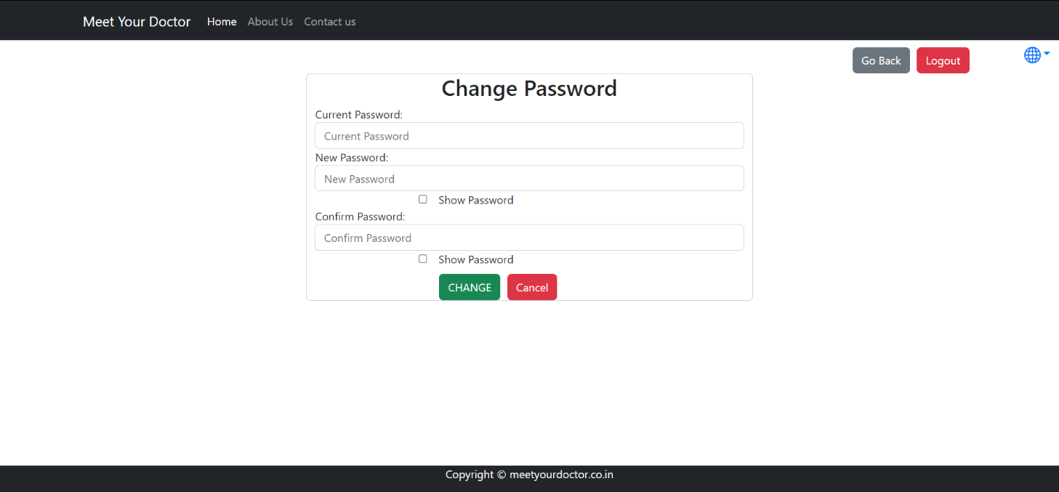

**8.4.7 Patient Book Appointment**

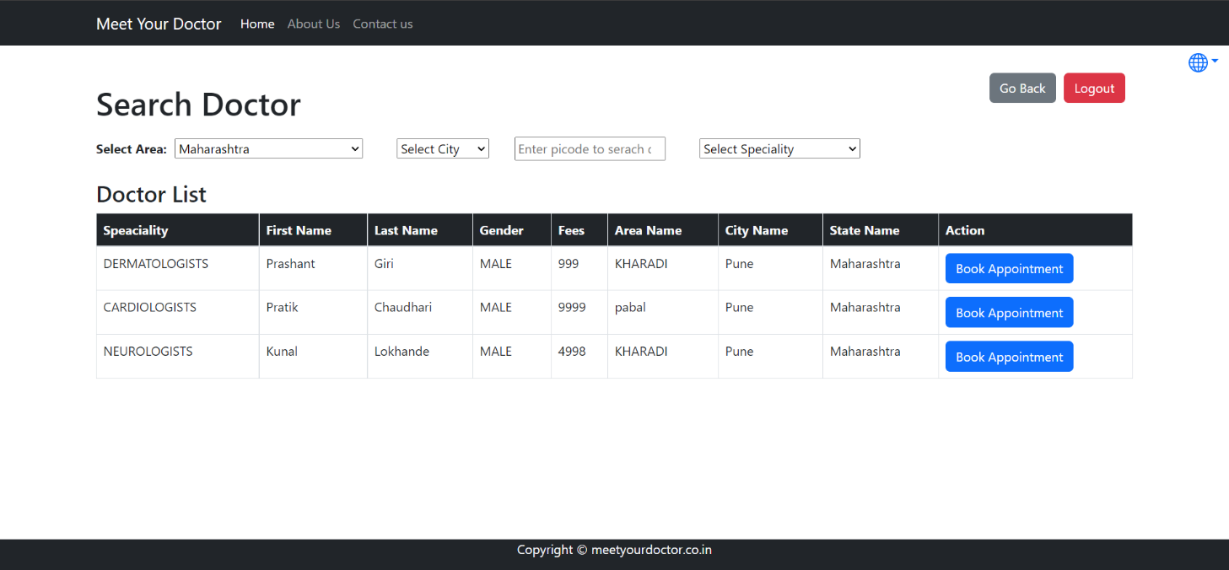

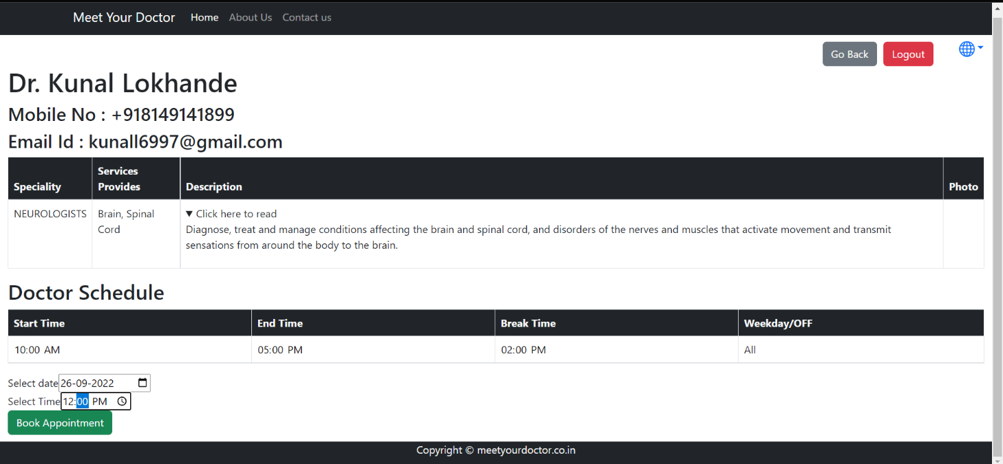

**8.4.8 Payment Page**

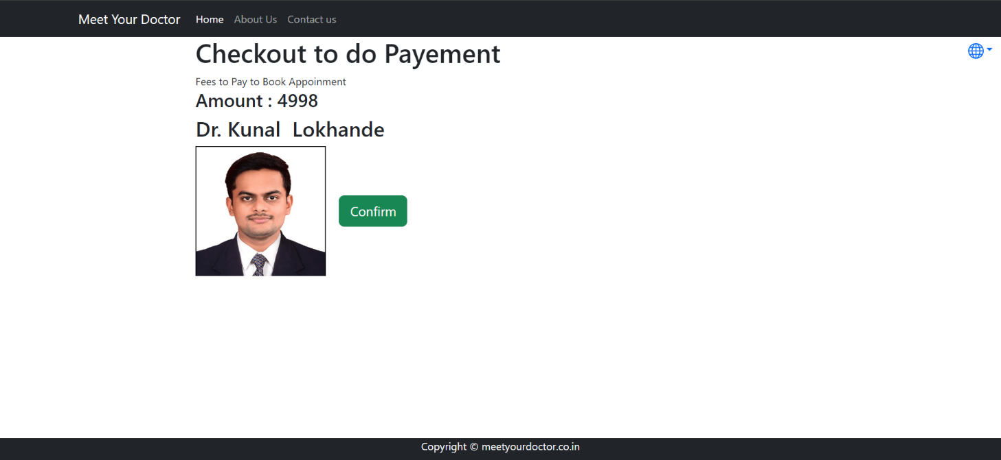

**8.4.9 Payment Dashboard**

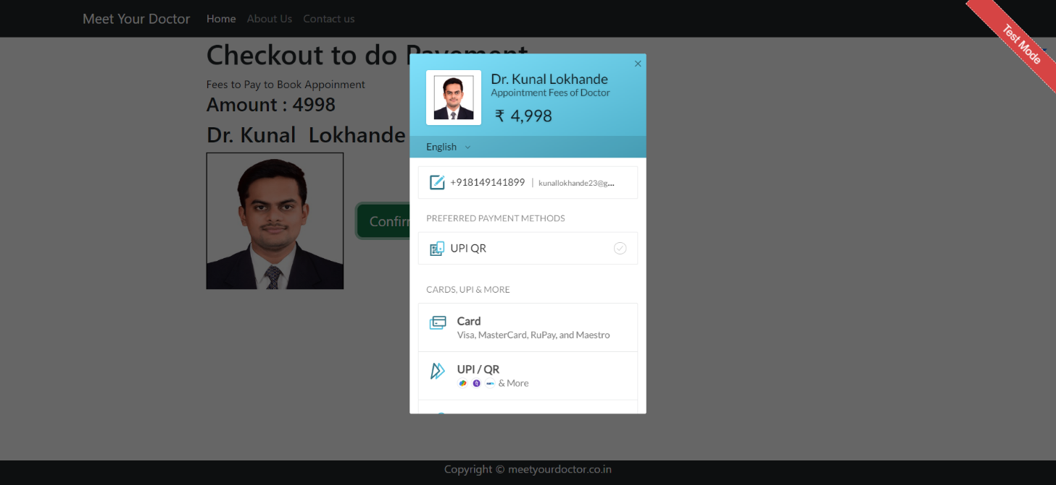

**8.4.10 Payment Success**

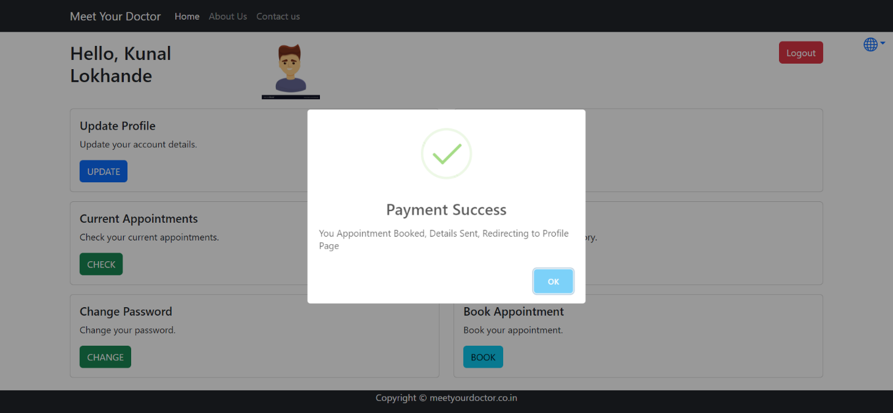

**8.5 Admin Dashboard**

**8.5.1 Admin Home Page**

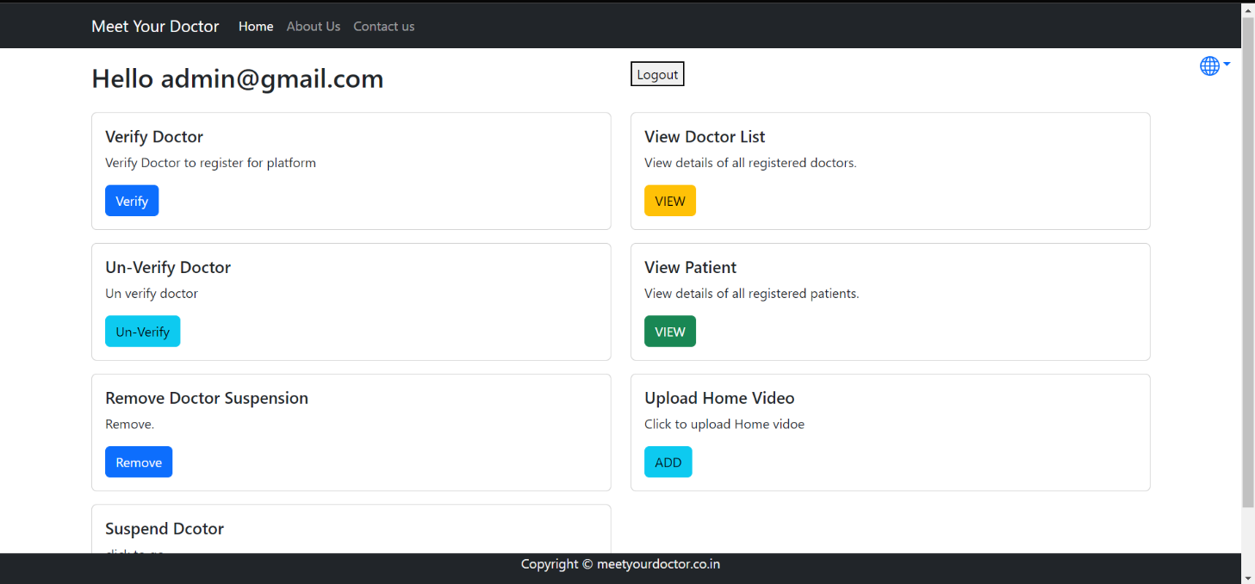

**8.5.2 Admin Verify Doctor**

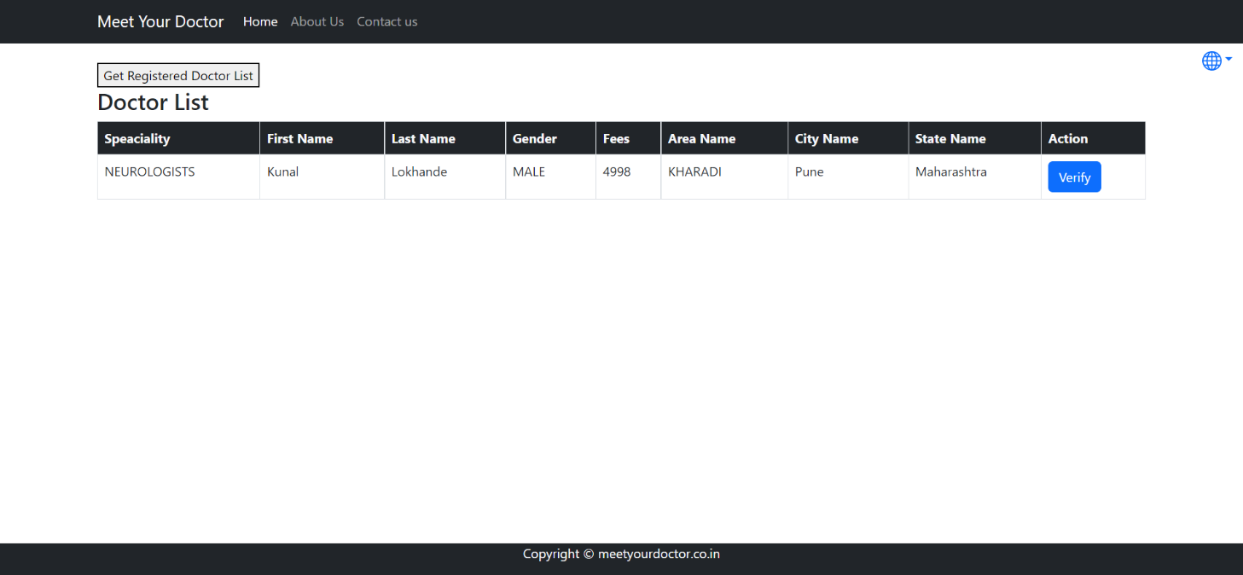

**8.5.3 Admin View Doctor List**

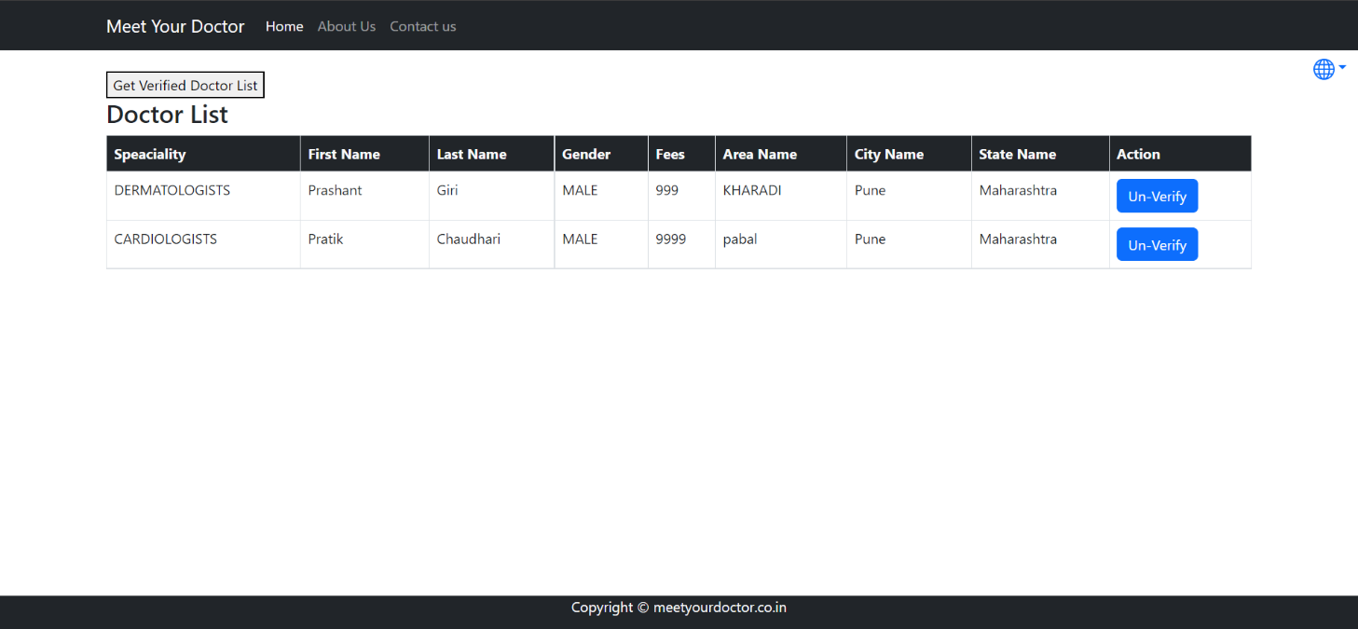

**8.5.4 Admin Un-Verify Doctor**

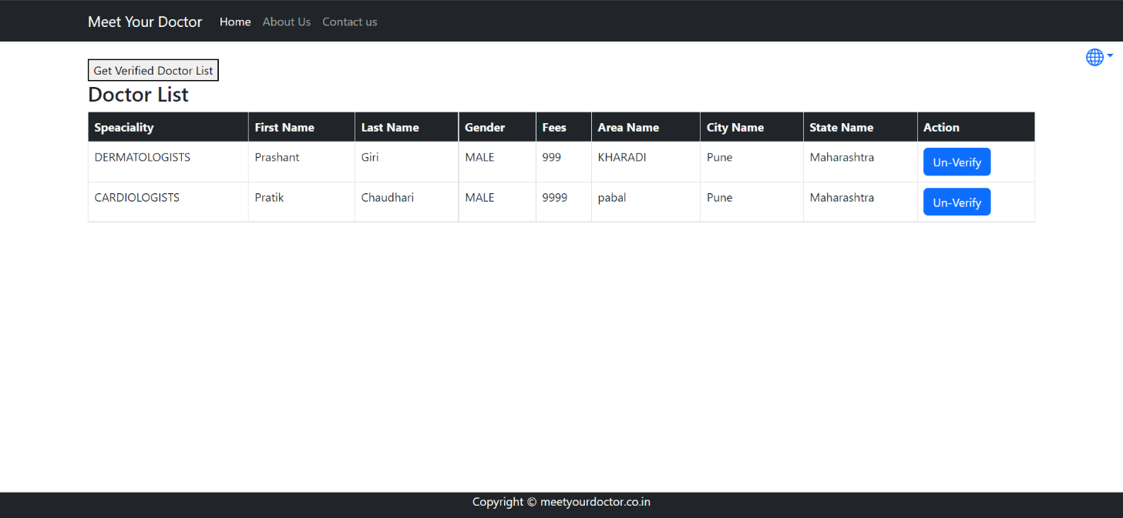

**8.5.5 Admin Remove Doctor Suspension**

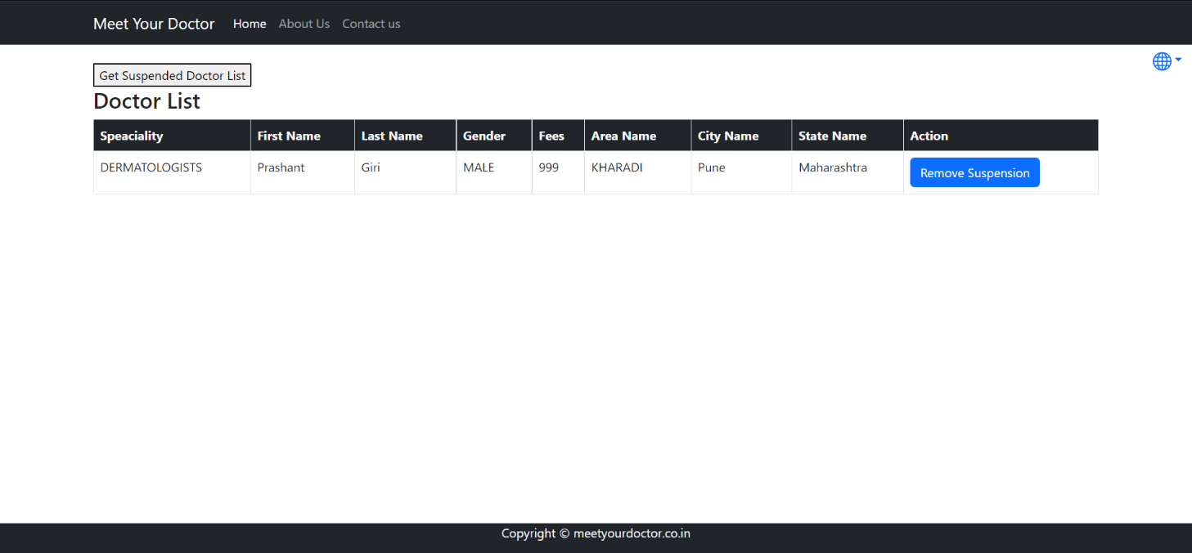

**8.5.6 Admin View Patient List**

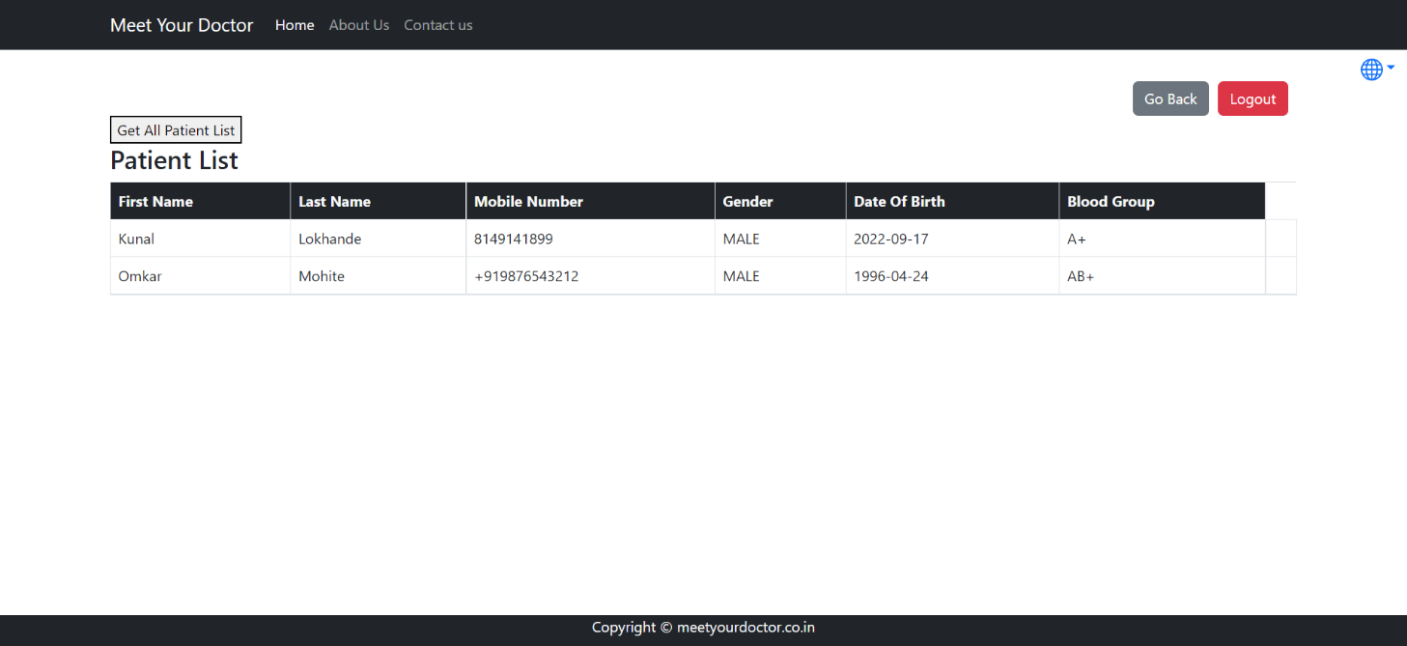

**8.5.7 Admin Add Home Video**

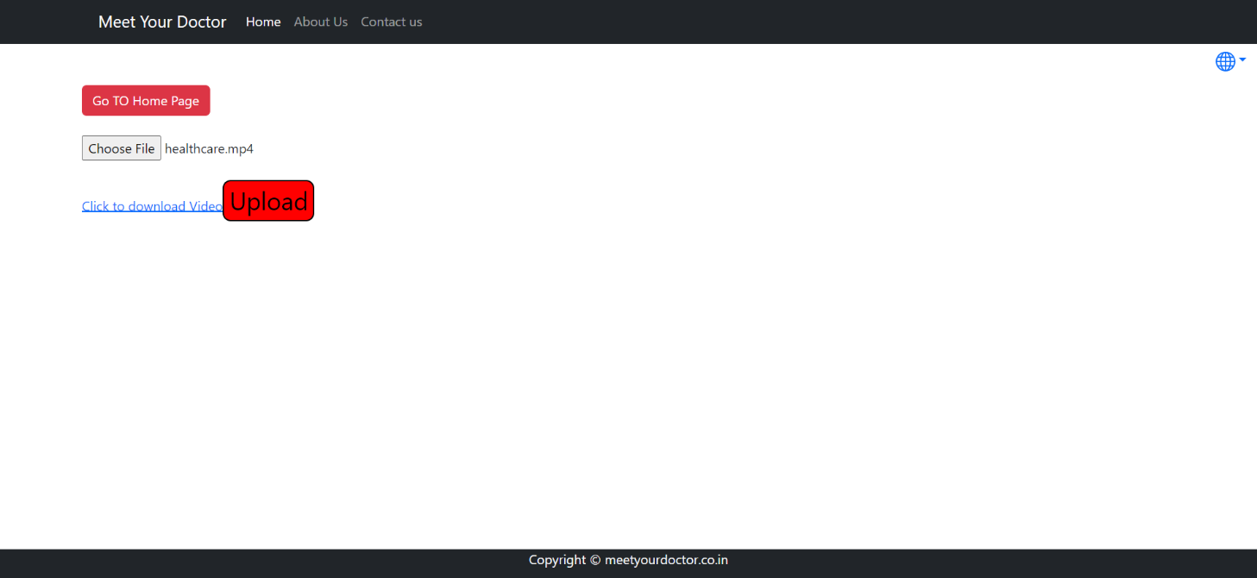

**8.5.8 Admin Suspend Doctor**

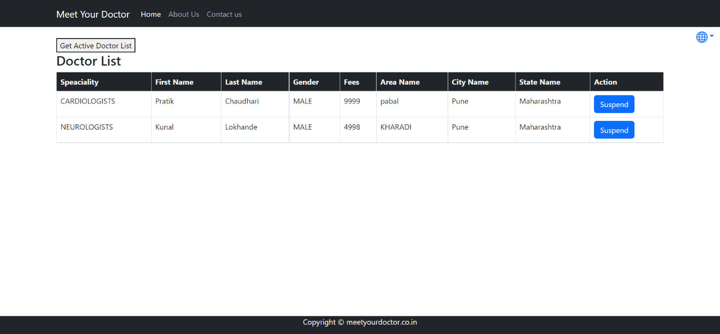

**8.6 Doctor Registration Page**

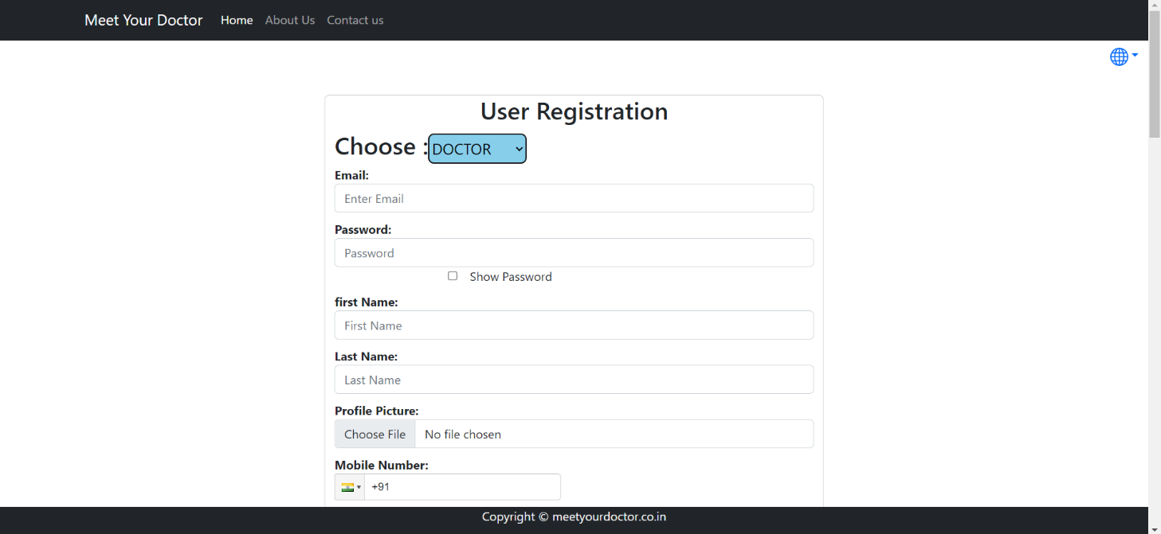

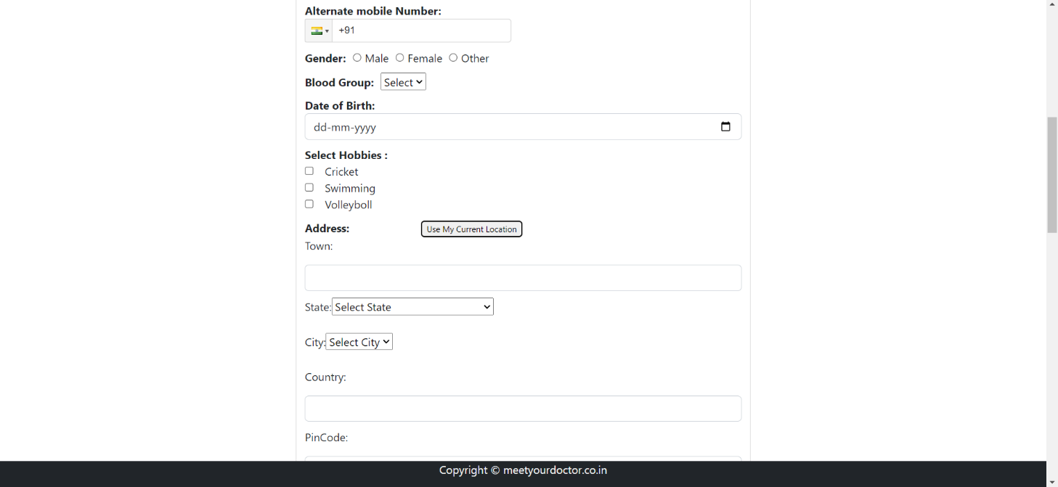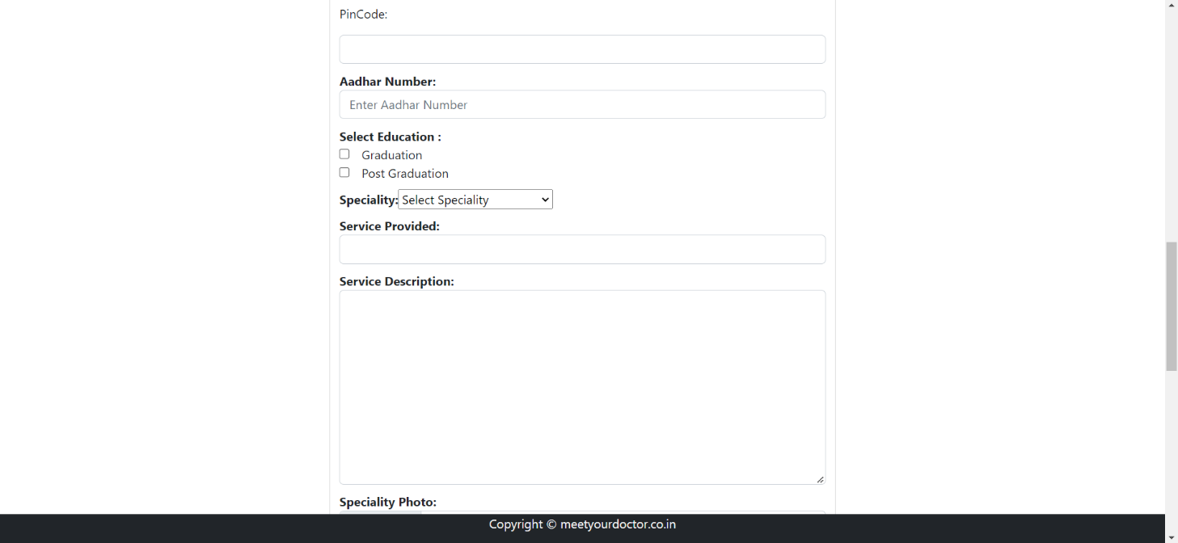

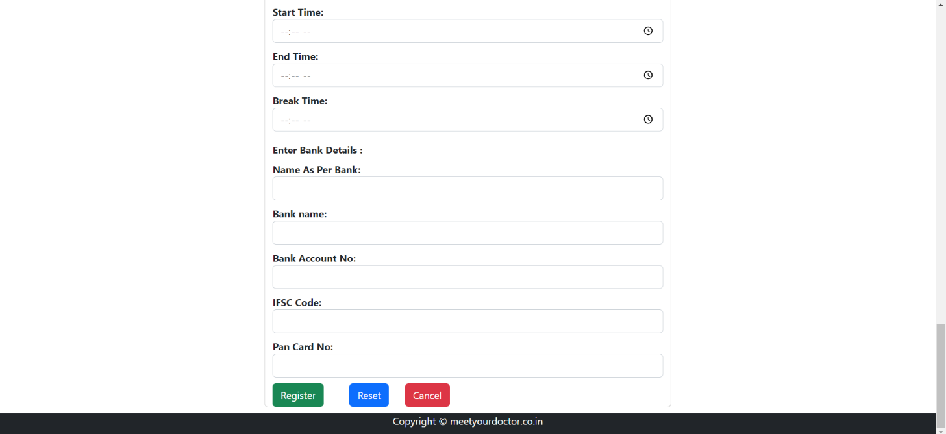

**8.6.1 Doctor Login**



**8.6.2 Doctor Dashboard**

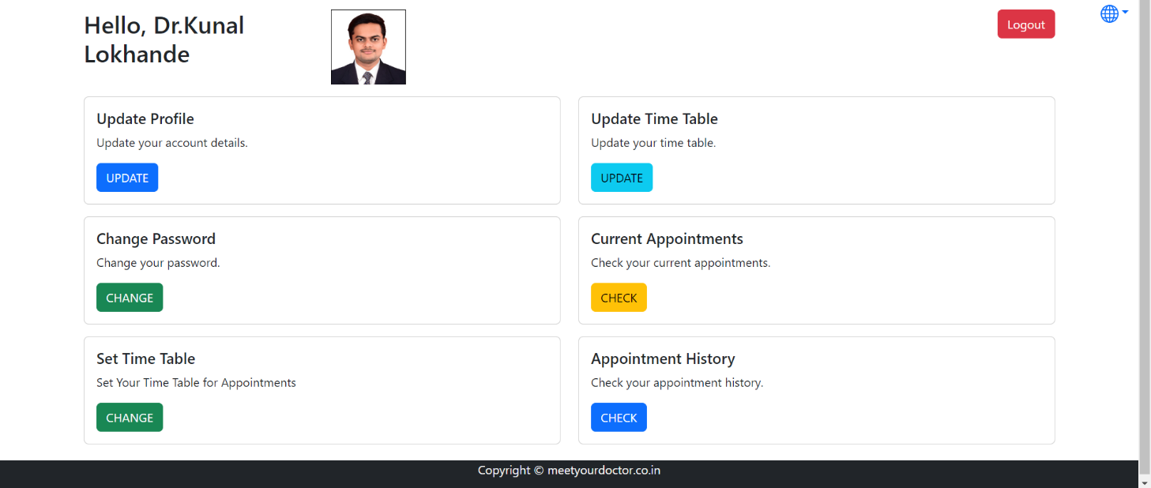

**8.6.3 Doctor Update Information**

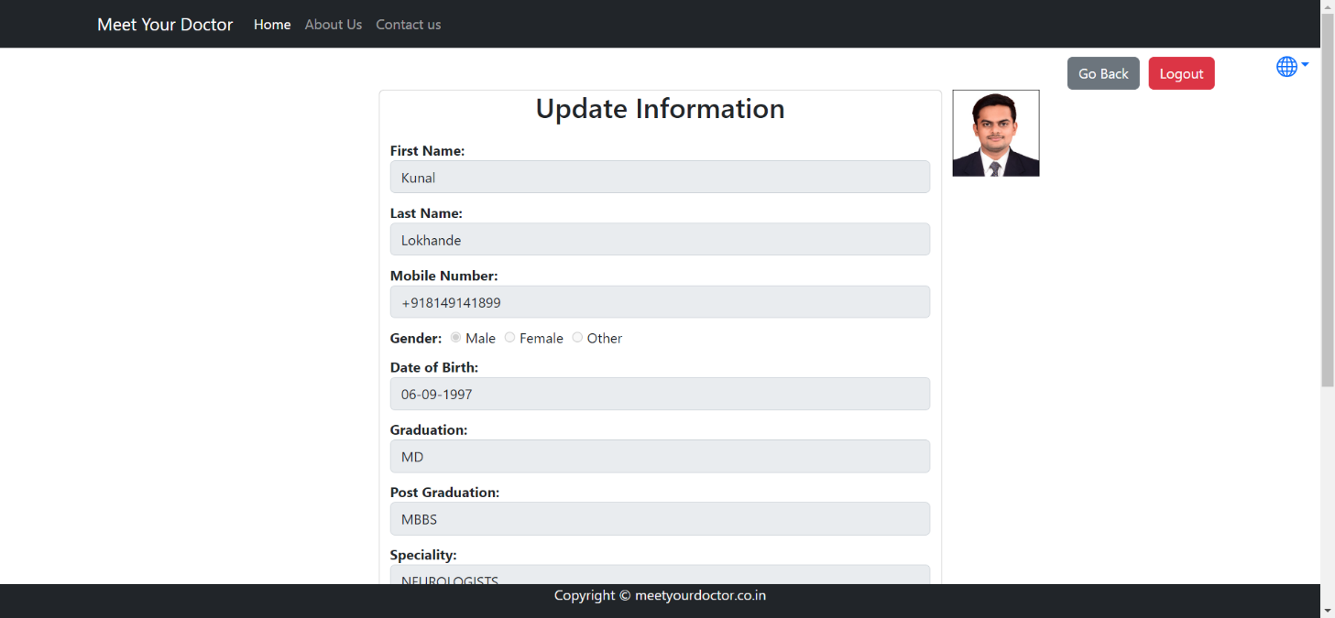

**8.6.4 Doctor Update Timetable**

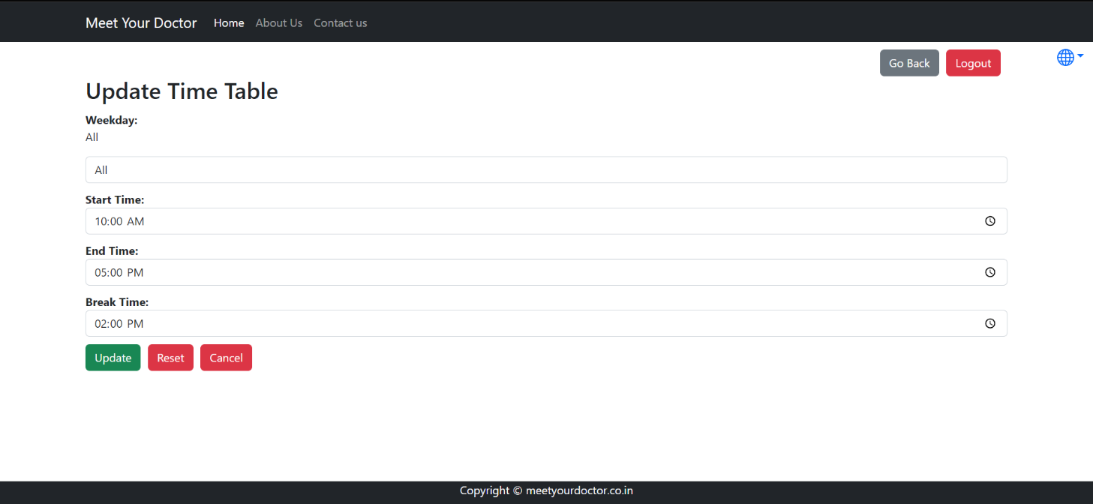

**8.6.5 Doctor Change Password**

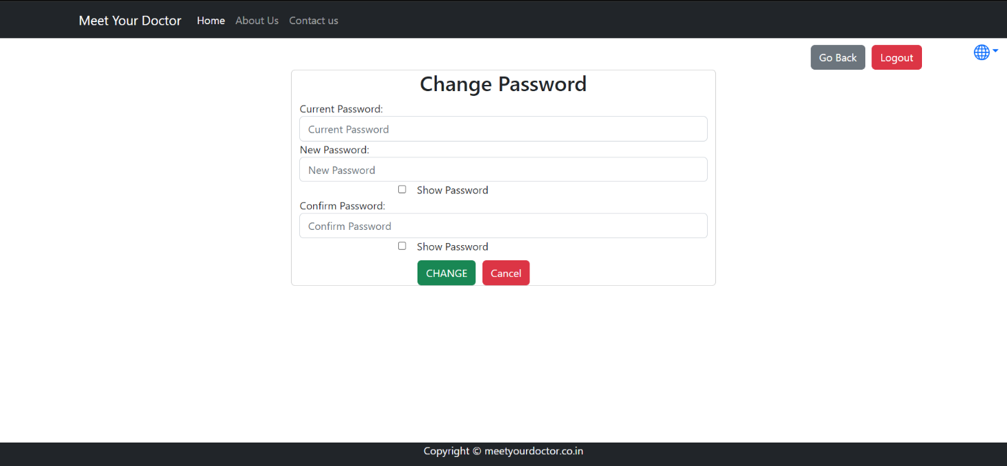

**8.6.6 Doctor Current Appointment**

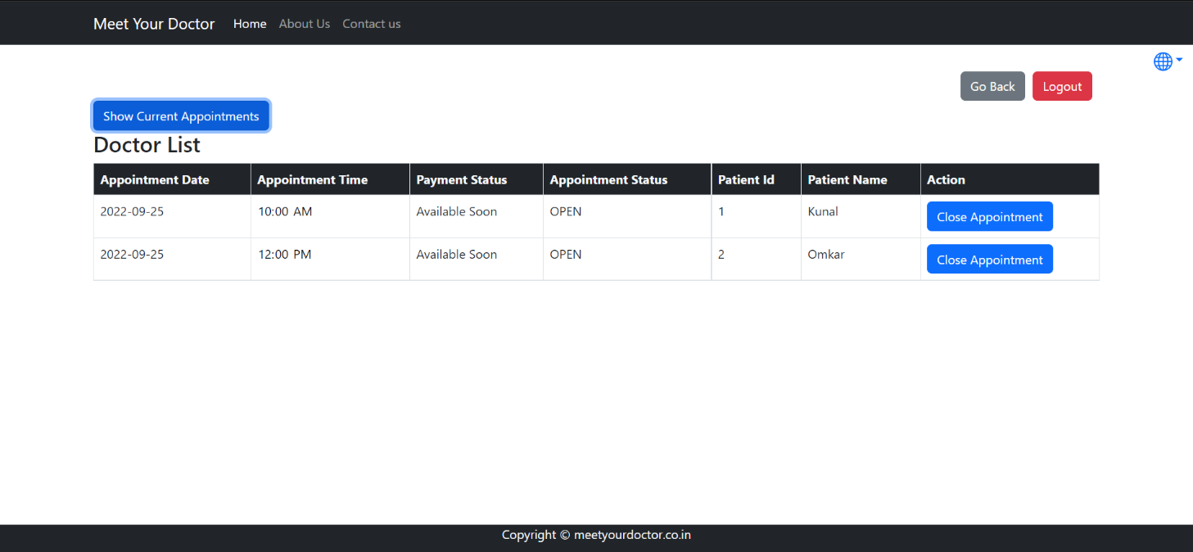

**8.6.7 Doctor Add Timetable**

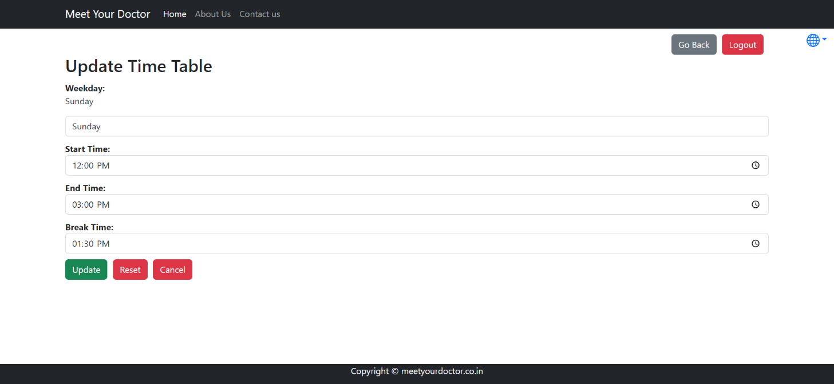

**8.6.8 Doctor Appointment History**

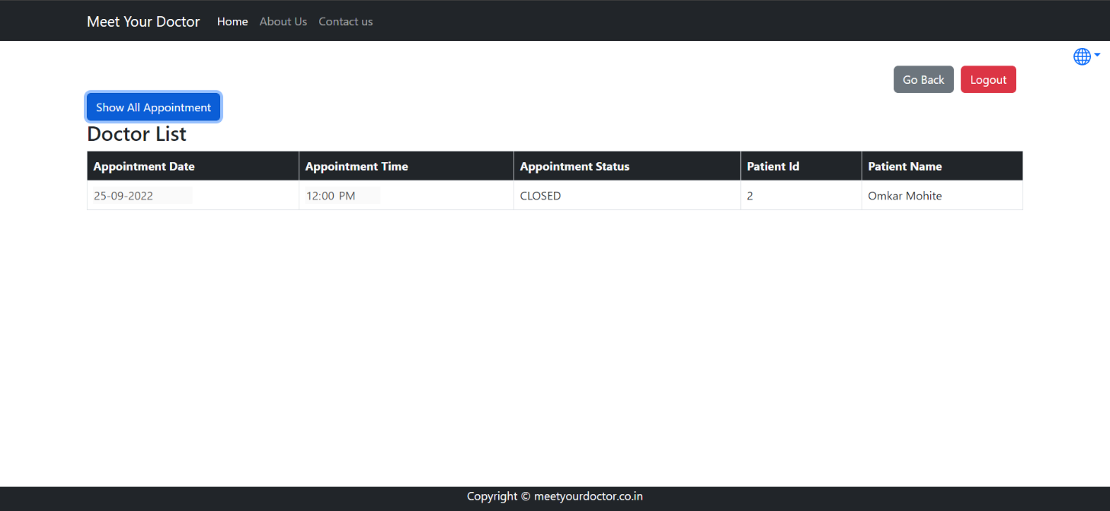

**9. CONCLUSION AND FUTURE SCOPE**

**9.1 Future Scope**

• We can add Online Consultation.

• Home visit of doctor.

• Blood Bank.

• Pathology (Home Service).

**9.1 Conclusion**

Internet is changing the world. Though it is not possible to entirely switch the healthcare sector to online mode. But definitely it can help in bridging the gap between Patient and Doctor. Our project Meet Your Doctor serves the purpose of bridging the gap. It makes easy for the patient to search for the doctor in his/her locality or in any other locality. Addition to this patient can also search for the doctor based on the doctor’s specialty.